SIMATS ENGINEERING
ASSESSMENT TOOL 3

COURSE NAME: Database Management Systems COURSE CODE: CSA0508

COURSE OUTCOME COVERED

CO2: Apply the relational model, relational algebra, SQL query structures, and views to solve database querying and data manipulation problems. (BL3, BL6)

Activity Tool : Debugging & Optimisation Task (Low) Assessment Tool Weightage: 30%

Dr.G.Ayyappan

QUESTIONS Total Marks: 50
Q.No | Question | Bloom's Level | Marks
1 | Identify and fix the error in the given SQL query that uses incorrect JOIN syntax and returns duplicate results. | BL3 – Apply | 5
2 | The following sub-query returns incorrect results due to a missing correlation. Debug and rewrite it correctly. | BL3 – Apply | 5
3 | A given SQL view definition causes errors when queried. Identify the issue and rewrite a correct and optimized view. | BL3 – Apply | 5
4 | Debug the given relational algebra expression that produces incorrect output for a natural join operation. | BL3 – Apply | 5
5 | The SQL query below violates referential integrity. Identify the violation and modify the statements to enforce proper constraints. | BL3 – Apply | 5
6 | Given an inefficient SQL query with nested loops, rewrite it using JOIN to optimize performance. | BL6 – Create | 5
7 | The GROUP BY query below produces wrong aggregation results. Debug the query and explain the error. | BL3 – Apply | 5

8 | Identify and fix the logical error in a given SQL UPDATE statement that unintentionally modifies all rows in the table. | BL3 – Apply | 5
9 | Optimize the given multi-table SQL query by restructuring sub-queries into JOINs and using appropriate indexes. | BL6 – Create | 5
10 | Debug a given relational calculus expression that returns an empty result set due to incorrect quantifier usage. | BL3 – Apply | 5

Code of Conduct:

I APSAL HAMEED J(192524286) certify that this submission is my original work and that I have adhered to the guidelines specified for this assessment.
I understand that any violation of academic integrity rules will result in disciplinary action.

Signature of the student:

RUBRICS FOR CALCULATION:

Criteria | Weightage | Level 4 (Exemplary) | Level 3 (Proficient) | Level 2 (Developing) | Level 1 (Beginning)
Problem Identification | 20% | Accurately identifies all errors and root causes with clear  understanding | Identifies most errors with minor gaps | Identifies some errors but misses key issues | Unable to identify errors correctly
Debugging | 25% | Applies systematic debugging techniques effectively to  resolve issues | Uses appropriate debugging methods with minor errors | Limited debugging approach; requires guidance | Unable to debug or resolve issues
Optimization | 20% | Optimizes code by significantly improving time complexity using efficient  algorithms | Improves time complexity with minor gaps in efficiency | Limited improvement in time complexity | No improvement; inefficient approach retained

Analysis | 20% | Demonstrates strong logical reasoning and clear justification of  solutions | Shows reasonable analysis with some justification | Limited analysis; weak reasoning | No analytical reasoning demonstrated
Code Quality | 15% | Produces clean, well-structured code with proper comments and  documentation | Code is mostly clear with minor documentation gaps | Code lacks structure and proper documentation | Poorly written code with no documentation

- Incorrect JOIN Syntax and Duplicate Result

Theory
A JOIN is an SQL operation used to combine data from two or more tables based on a related column. Tables in a relational database are usually connected using primary keys and foreign keys. JOINs help retrieve related information stored in different tables.
An INNER JOIN returns only the records that have matching values in both tables. The relationship between the tables is normally specified using a JOIN condition.

Explanation
If the JOIN condition is incorrect or missing, the database may combine unrelated records. This can result in a Cartesian product, where each record from one table is combined with every record from another table. As a result, the query may return a large number of unwanted or duplicate-looking records.
For example, an Employee table may contain a department ID, while the Department table also contains the department ID. These two columns are used to establish the relationship between the tables. If they are not matched correctly, an employee may be associated with the wrong department.
Therefore, a proper understanding of primary keys, foreign keys, and JOIN conditions is important to avoid duplicate and incorrect results.
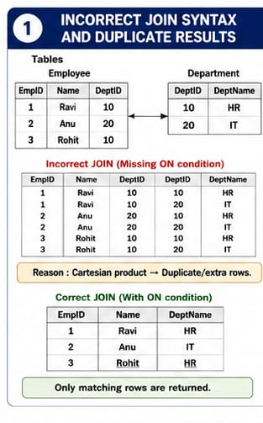

2. Missing Correlation in a Subquery

Theory
A subquery is a query placed inside another SQL query. It is used to obtain intermediate results that are required by the outer query. A subquery may be independent or correlated.
A correlated subquery is a subquery that depends on the outer query. It uses a value from the current row of the outer query while performing its operation.

Explanation
The problem occurs when a subquery that should depend on the outer query is written independently. In such a situation, the inner query may calculate its result using the entire table instead of the specific record currently being processed.
For example, when comparing an employee's salary with the average salary of that employee's department, the average should be calculated only for that particular department. If the subquery is not correlated, it may calculate the average salary of all employees.
This produces logically incorrect results because the inner query is not considering the relationship between the current outer record and the corresponding records in the inner query.
Correlation establishes a connection between the outer query and inner query and allows the
subquery to produce a result based on the current row.

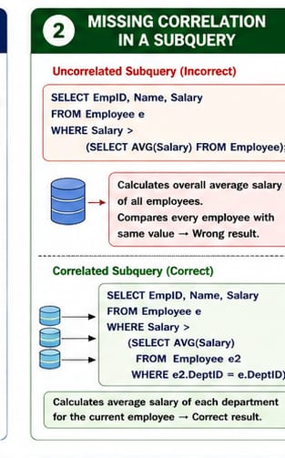

3. SQL VIEW Definition

Theory
A VIEW is a virtual table created from one or more existing tables. It is based on a SELECT query and provides a customized way of viewing data. A view normally does not store a separate copy of the data; instead, it represents the result of the underlying query.
Views are commonly used for data security, simplifying complex queries, hiding unnecessary columns, and providing users with a convenient representation of database information.

Explanation
An error in a view definition can occur because of an incorrect SELECT statement, invalid column names, ambiguous attributes, or incorrect relationships between tables.
For example, if a view combines Employee and Department information, the relationship between the two tables must be correctly established. If the relationship is not properly defined, the view may produce incorrect results or may not execute successfully.
A view should contain appropriate columns and valid relationships between all the tables involved. The underlying tables and their relationships must also remain consistent for the view to work correctly.
Thus, a properly defined view provides a simplified and controlled interface to the underlying database tables.

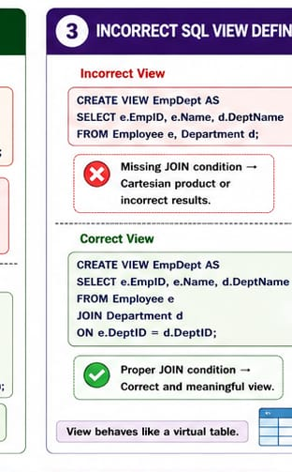

4. Natural Join in Relational Algebra

Theory
Relational Algebra is a formal query language used to perform operations on relations in a relational database. Important relational algebra operations include selection, projection, union, intersection, difference, Cartesian product, and join.
A Natural Join combines two relations using their common attributes. It matches tuples where the values of the common attributes are equal and normally removes duplicate copies of the common attribute from the final result.

Explanation
The correctness of a natural join depends on the common attributes between the relations. For example, an Employee relation may contain Dept_ID, and a Department relation may also contain Dept_ID. This common attribute represents the relationship between the two relations.
If unrelated attributes are considered common, or if the relation structure is not properly defined, the natural join can produce incorrect results. Records may be combined even though they do not represent a valid relationship.
A natural join is therefore useful when relations have clearly defined common attributes. The attributes should have the same meaning and compatible domains.
The main purpose of the natural join is to combine related information while avoiding unnecessary combinations of unrelated tuples.

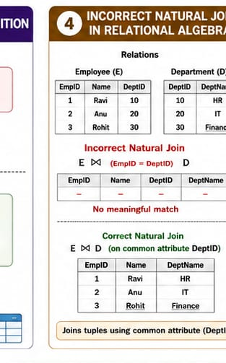

5. Referential Integrity

Theory
Referential integrity is a database constraint used to maintain consistency between related tables. It is mainly implemented using foreign keys.
A foreign key in one table refers to the primary key of another table. The table containing the foreign key is called the child table, while the table containing the referenced primary key is called the parent table.

Explanation
A referential integrity problem occurs when a child table contains a foreign-key value that does not correspond to any value in the parent table.
For example, consider an Employee table and a Department table. If an employee record contains a department ID, that department ID should normally exist in the Department table. If it does not exist, the employee record refers to a department that is not present in the database.
Such invalid references can lead to inconsistent and unreliable data. Referential integrity prevents this problem by ensuring that relationships between tables remain valid.
It also controls certain operations such as insertion, updating, and deletion of related records. Depending on the database design, actions such as restricting deletion or automatically updating related records may be used.
Therefore, referential integrity is essential for maintaining accuracy and consistency in relational databases.

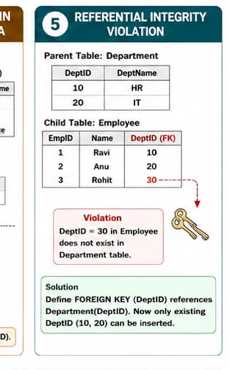
6. SQL Query Optimization Using JOIN

Theory
Query optimization is the process of improving the efficiency of a SQL query so that it requires less processing time and fewer system resources.
When databases contain a large number of records, inefficient queries can take a long time to execute. Nested loops, repeated table scans, unnecessary subqueries, and lack of indexes can reduce performance.

Explanation
A query that repeatedly searches one table for every record in another table can become inefficient when the number of records increases. This is particularly noticeable when large tables are involved.
JOIN operations allow related data from multiple tables to be retrieved based on their relationships. The database management system can then determine an efficient execution strategy for combining the tables.
Indexes can also improve performance. An index provides a faster way of locating records based on frequently searched or joined columns.
For example, when two tables are frequently related through a department ID, having an index on that column can reduce the amount of data the database needs to scan.
Therefore, query optimization is important for improving response time, reducing resource usage, and providing better performance for large databases.

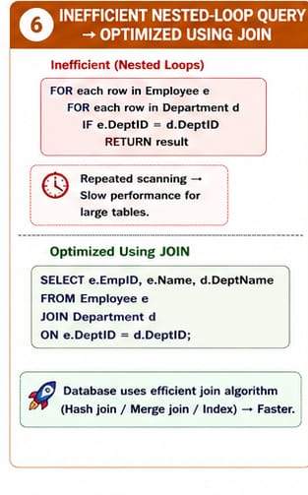

7. GROUP BY and Aggregation

Theory
The GROUP BY clause in SQL is used to arrange rows into groups based on one or more columns. It is generally used together with aggregate functions.
Important aggregate functions include:
COUNT – counts the number of records
SUM – calculates the total
AVG – calculates the average
MAX – finds the highest value
MIN – finds the lowest value

Explanation
The purpose of GROUP BY is to perform calculations separately for different groups of records.
For example, if an Employee table contains employees from several departments, GROUP BY can be used to group employees according to department. An aggregate function such as COUNT can then determine the number of employees in each department.
An error occurs when the query attempts to display a non-aggregated column that does not properly belong to the grouping criteria. The database cannot determine which value should be displayed when multiple records exist within the same group.
Correct grouping is therefore necessary to obtain meaningful aggregation results.
GROUP BY is widely used in reporting and data analysis because it allows large amounts of data to be summarized according to categories or groups.

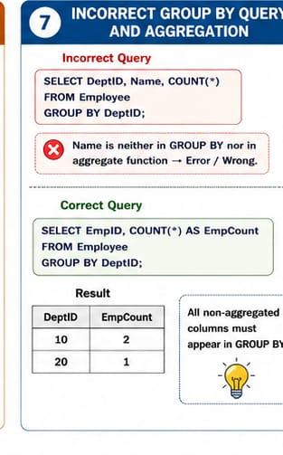

8. UPDATE Statement Modifying All Rows

Theory
The UPDATE statement is used to modify existing data in a database table. It can change one or more columns of existing records.
The WHERE condition is used to identify the particular records that should be affected. If a WHERE condition is not specified, the UPDATE operation generally applies to all records in the table.

Explanation
The logical problem occurs when an UPDATE statement unintentionally affects every row.
For example, suppose a database administrator wants to modify the salary of only one employee. If the statement does not specify which employee should be modified, the same salary modification may be applied to every employee.
This can result in serious data inconsistency. An accidental update to thousands of records can be difficult to identify and restore, particularly if proper backups are not available.
The problem is therefore related to incorrect row selection during the update operation. The database must be able to distinguish between the records that need modification and those that should remain unchanged.
Careful use of UPDATE statements is essential because they directly modify stored data.

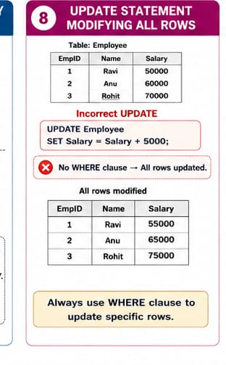

9. Multi-Table SQL Query Optimization

Theory
A multi-table query retrieves information from more than one table. Since relational databases divide information into separate tables, JOIN operations are commonly required to combine related data.
Query optimization attempts to reduce the amount of work performed by the database while producing the same required result.

Explanation
A multi-table query can become inefficient when it contains many nested subqueries. Each nested operation may require additional processing, particularly when large tables are involved.
JOINs can often provide a more efficient way to connect related tables. They allow the database optimizer to determine an appropriate execution plan for retrieving the required information.
Indexes also play an important role in optimization. Columns frequently used for JOIN operations, searching, filtering, and sorting can benefit from indexing.
However, indexing every column is not desirable because indexes require additional storage and may increase the time required for INSERT, UPDATE, and DELETE operations.
Therefore, efficient multi-table queries require a balance between proper JOIN operations, appropriate filtering, and carefully selected indexes.

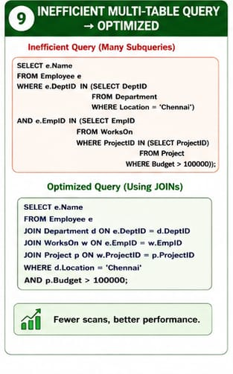
10. Quantifiers in Relational Calculus

Theory
Relational Calculus is a non-procedural query language based on mathematical predicate logic. It describes the conditions that the required data must satisfy rather than specifying the exact steps used to retrieve it.
Two important quantifiers used in relational calculus are:
Universal quantifier (∀) – means "for all"
Existential quantifier (∃) – means "there exists"

Explanation
The quantifier determines how a condition is applied to records in a relation.
The universal quantifier (∀) requires the specified condition to be true for every relevant record. It is therefore a very restrictive condition.
The existential quantifier (∃) requires the condition to be true for at least one record. It is useful when we only need to establish that a matching record exists.
If a universal quantifier is used when only one matching record is required, the condition may become unnecessarily restrictive. The expression may then return no records because it is unlikely that every record in the relation will satisfy the given condition.
For example, when checking whether an employee belongs to a particular department, it is sufficient to find one department record that matches the employee. Requiring the condition to be true for every department would be logically incorrect.
Therefore, understanding the difference between ∀ (for all) and ∃ (there exists) is essential when writing relational calculus expressions.
